Nutcache - GitHub Integration

Follow these steps to enable nutcache version control integration with GitHub.

1. Click the integration icon to begin.

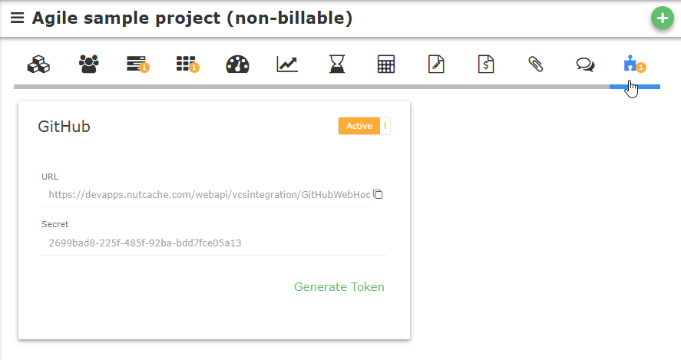

1. Click the toggle button to activate GitHub integration.
2. Nutcache automatically generates the web hook url and the secret needed to complete the integration in GitHub. These values can be changed if needed.
3. In GitHub go to settings option for your repository

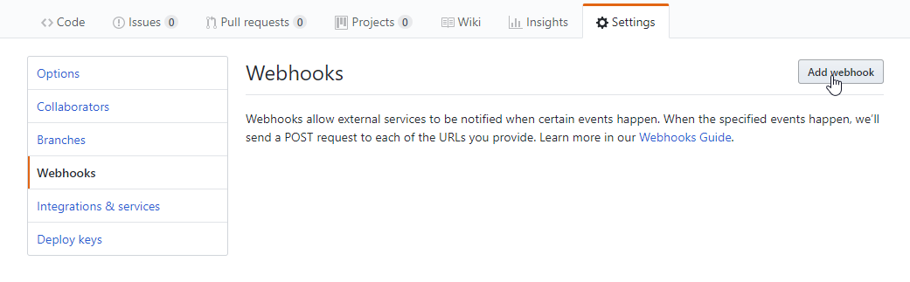

1. Click Add webhook
2. Complete the form with the url and secret supplied by nutcache.

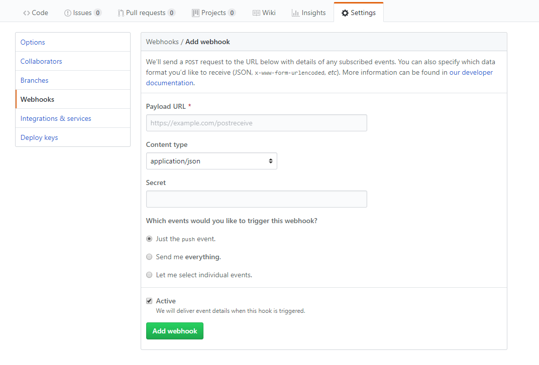

1. Make sure Content type is application/json
2. Customize the level of notifications desired



Click Add webhook and you are done.

NB To link Github changes to a Nutcache story or stories, use the comment or message section in Github as follows. Character “S” and the story number.

Ie S314 or s314 to link to Nutcache story 314

Ie S215, S216 to link to Nutcache stories 215 and 216